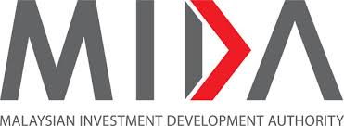
www.mida.gov.my
New Automation CA Checklist - Manufacturing
(19.06.2024)

CHECKLIST FOR
APPLICATION OF NEW AUTOMATION CAPITAL ALLOWANCE
FOR MANUFACTURING SECTOR

1. | Application Form to be uploaded in the InvestMalaysia portal under the General Application module
2. | A copy of Business License (mandatory requirement)
3. | A copy of Manufacturing License, or  A copy of Confirmation Letter for Exempted from Manufacturing License (whichever is applicable)
4. | A copy of tax incentive approval letter(s) (if applicable)
 | Following documents are to be certified by External Auditor:
5. | List of purchased and installed machinery/ equipment/ software/ system
6. | Invoices/Purchased Orders and Delivery Orders for the machinery/ equipment/ software/ system.
7. | Proof of documents to indicate the full payment for machinery/ equipment/ software/ system has been paid.

